INTRODUCTION TO MEASURING WATER QUALITY
WHAT IS WATER QUALITY?
Water quality measures how clean or dirty a stream may be. It is the condition of water according to the known requirements of the animals that may be living in or using the water – including humans! For example, to know if a body of water is safe for people to touch, swim in, fish from, or even drink, water quality must be tested. Tests for water quality help to understand if a waterbody is affected by pollution, and if so, what type(s) of pollution.
HOW CAN WATER QUALITY BE MEASURED?
Water quality can be measured many ways, using many different types of tests and equipment. Essentially, water quality is measured by looking at one or more of the following characteristics:
Chemical – substances or compounds in the water created from chemical elements. For example, salt (sodium + chloride) is considered a chemical.
Biological – the organisms living in the water. Fish, insects, plants, bacteria and algae are examples of aquatic organisms commonly used to measure quality.
Physical – the characteristics of water that can be seen (color), smelled (odor), or felt (temperature).
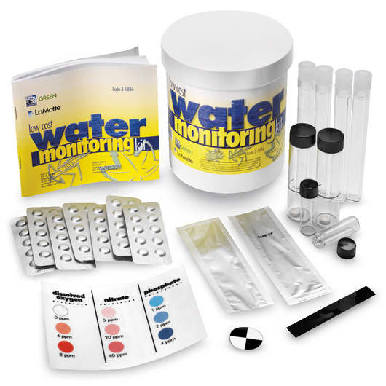
HOW WILL YOU MEASURE WATER QUALITY?
For this activity, you will measure the water quality of a local stream using the water test kit shown on the right. This test kit includes all the supplies you will need to measure chemical, biological, and physical water quality. The kit you will be using includes tests for:

- Temperature
- Dissolved oxygen
- Biological oxygen demand
- pH

- Turbidity
- Nitrate
- Phosphate
- Fecal coliform

Together, the results of these tests will provide a complete assessment of water quality.


Before collecting your water sample, be sure to read the instructions and safety notes for collecting water samples provided with the test kit (page 8, page 10).

SELECTING A STREAM SITE

WHERE SHOULD YOU COLLECT YOUR WATER SAMPLE?
Picking a stream site is an important first step and there are some things you should consider:
- Go to the stream with another person and let someone else know where you are going.
- Pick a stream site that is easy and safe to access, make sure:
  - You can easily get to the stream
    - Banks not too steep
    - Ground is stable
  - The water is shallow
  - The water is not moving too fast
  - The water and surrounding area does not appear to be hazardous (for example, no oil spills, garbage, etc.)
- Be prepared to get wet!
  - Wear old clothes and shoes, just in case
WHAT CAN YOU TELL US ABOUT THE STREAM YOU CHOSE?
In order to understand the results of the water tests you are about to perform and make inferences about stream health, it is important to fully observe where you are collecting the sample. Make a map drawing of the stream site in the box below. Make note of major features, such as big trees, boulders, eroding stream banks, sharp turns in the stream, and so on. Make notes on the map where exactly in the stream you collected your sample.
COLLECTING YOUR WATER SAMPLE
Once you have picked a stream site to measure water quality, you must collect your water sample. To help get you started, the video, “Introduction to Water Testing” is available on OEI’s website (www.oei2.org/water-quality-sampling/).
To be consistent, it is important to perform all of the tests from the same sample of water. To do so, you will use the plastic cup that all of the test supplies come in. Empty the contents of the cup and make sure the testing supplies stay in a safe and dry place while collecting your water sample. To collect your water sample:
- Before getting started, affix the temperature stickers to the outside of the cup and the turbidity sticker (black & white round disc) to the inside bottom of the cup, if not already done so
- Take the cap off the cup
- Place the cup in the stream so that the opening of the cup is facing upstream (into the current)
- Let the water flow into the cup for 30 seconds
- Fill the cup as much as you can
- Bring the sample to shore and begin performing the water quality tests. All tests will be performed using this water sample, so be sure to fill the cup as much as possible.
- Short videos are available to assist you with each test at: www.oei2.org/water-quality-sampling/

- Dissolved oxygen and Biological Oxygen Demand tests should be started within the first several minutes of collecting the water sample to get as accurate of a reading as possible.

